**Wireless Cold Chain Monitor**

# Product description

* Monitor critical parameters such as temperature and relative humidity in real time.
* Temperature reporting interval can be configured between minimum of once every second to maximum of once every day.
* Each message from sensor data conveys current temperature and battery voltage data.
* WiSense gateway can support up to 64 simultaneous sensor nodes in a single network
* Built on top of our proven Sub-GHz RF mesh platform and RF to Cellular connectivity.
* Wireless communication between gateway and sensor nodes is bi-directional. This allows node behavior to be reconfigured during installation and at any time after installation

# Product Applications

* Can be used anywhere in the cold chain - from large cold rooms to small ice-boxes in warehouses
* Mobile refrigeration units

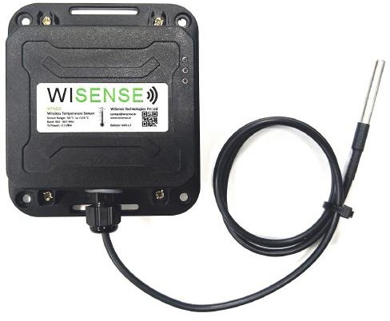

# Product Technical Specifications

* Input supply voltage: 3.0 V to 4.2V using

1 x Rechargeable LI-Ion / 2x AAA batteries

* Very low standby mode current consumption of 2 uA allows for long battery life
* Sensing temperature range: -50 deg C to +125 deg C
* Accuracy: ±0.5°C ( -10°C to +85°C)
* Maximum transmit power: +13 dBm
* Wireless Operating Frequency India: 865 to 867 MHz, EU: 868 MHz & USA: 900 MHz
* Wireless range: 1km (line of sight)
* Antenna Type: Half-wave dipole, gain: +3dBi
* Dimension: 103 mm x 116 mm x 33 mm

# Our Other Products

* Ambient Humidity and Pressure Sensor node
* Wireless temperature monitor tag
* Wireless load Cell monitor node
* Solar Li-ion Charger board, Wireless weather station
* PIR sensor node, Door sensor node
* Emergency wall buttons

WSN Mesh network

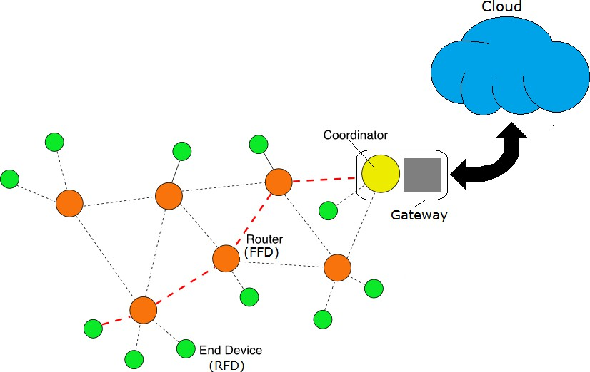

Reefer with Wireless senor nodes & Gateway

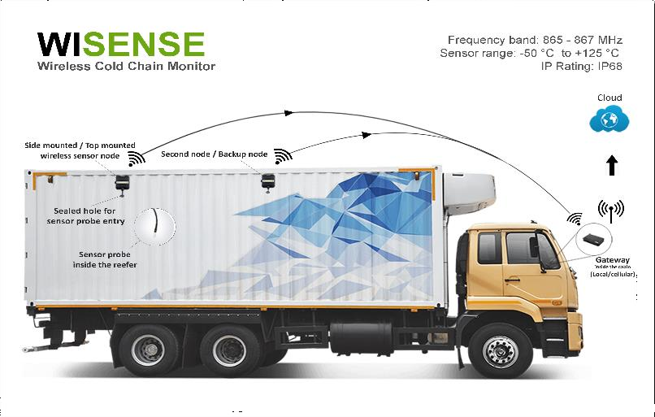

Sensor’s data visualized in the cloud

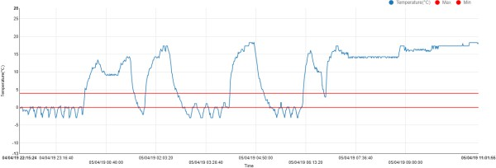

**Wireless Door Sensor Node**

# Product description

* Small form factor wireless door sensor node
* Message sent on every status change (open/close) of the door to the central coordinator.
* Each message from sensor data conveys door Status, Battery voltage and MAC address of the device.
* Powered by two-coin cells (3V CR2032) which can last more than three years assuming 1 transmission every 5 Minutes.
* The node has an internal PCB antenna
* Very low power consumption(<2uA),
* LED indicator for door Open/Close status
* Software configurable LED light color and blinking interval

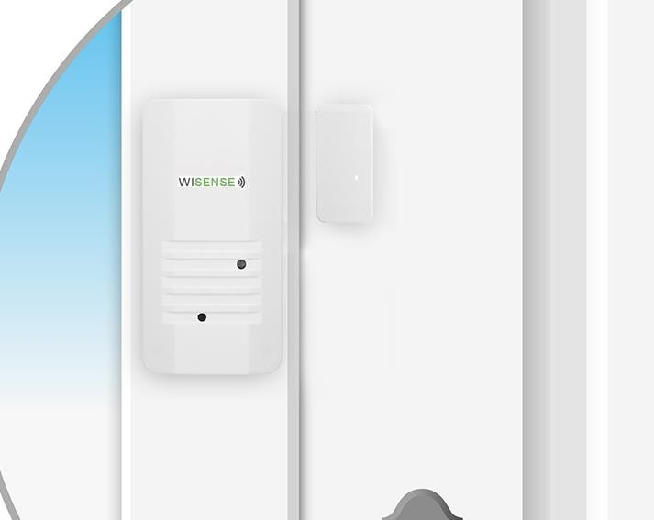

# Product Applications

* Facility management
* Industrial door status monitoring
* Security and monitoring purpose
* Home/building automation
* Smart buildings

# Product Technical Specifications

* Input supply voltage: 1.8 to 3.0 V DC
* Current consumption: <2 microamps (Sleep mode)
* Response time: < 1 Second
* Maximum transmit power: +10 dBm
* Wireless range: 70-80 metres
* Antenna Type: PCB
* Operating Temperature: -25° to +100° Celsius
* Data rate: 1.2kbps - 100kbps
* Enclosure Material: ABS
* Certifications: FCC, ETSI, WPC/GOI compliant radio for India



WSN Mesh network



Snapshot of the sensor’s data visualized in the cloud

**Wireless Humidity Sensor Module**

# Product description

* Wireless humidity sensor uses CC2D33S Amphenol Advanced Sensors measures range 0 to 100 % with

+/- 3% accuracy

* Temperature sensor uses NXFT15XH103 NTC thermistor (Murata) measures range -40 deg C to

+125 deg C

* Each message from sensor data conveys current humidity, temperature and battery voltage data.
* Reporting interval 1 second or more (configurable in real time via network coordinator)
* Powered by 2XAAA Batteries (Inside or outside enclosure)
* Very low standby mode current consumption of 2 uA allows for long battery life
* Sensor operate in the 865-867 MHz license free band in India.

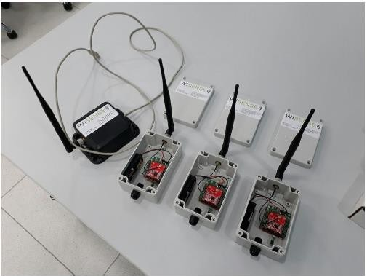

# Product Applications

* Indoor ambient humidity and temperature measurement
* Cold storage, ware houses
* Environmental monitoring
* For HVAC Systems (Heating Ventilation & Airconditioning)

# Product Technical Specifications

* Input supply voltage: 1.5 to 3.0 V DC
* Current consumption: <2 microamps (Sleep mode), 2 micro amps (Active mode)
* Sensing humidity: Range: 0 to 100 %, Accuracy: +/- 3%, No calibration required
* Sensing temperature range: -40 deg C to +125 deg C
* Response time: < 1 Second
* Maximum transmit power: +13 dBm
* Each node has a unique IEEE assigned 64 bit address
* Wireless range: 1.0 k.m (line of sight)
* Antenna Type: Half-wave dipole, Gain: +3 dBi
* Enclosure Material: ABS
* Dimensions: 120 mm x 80 mm x 50 mm



WSN Mesh network



Snapshot of the sensor’s data visualized in the cloud

**Wireless Load Sensor Node**

# Product description

* Wireless load cell sensor measures load/ weight of materials
* Reports measured load value periodically with configurable interval - Minimum (1 sec) / Maximum (1 day)
* Reports measured load only when it changes by a configurable percentage value with respect to the prior value reported
* Each message from sensor data conveys load values and battery voltage data.
* Powered by 2 x AAA or 2 x AA Batteries or one 1 x Rechargeable LI-Ion (3.7V to 4.2V) battery
* Very low standby mode current consumption of 2 uA allows for long battery life
* Sensor operate in the 865-867 MHz license free band in India.

# Product Applications

* LPG cylinder gas weight (level)
* Industrial weighing gauges
* Fitness equipment

# Product Technical Specifications

* Input supply voltage: 3.0 to 5.0 V DC
* Current consumption: <2 microamps (Sleep mode), 2 micro amps (Active mode)
* Sensing load range: 0 to 1000 Kg
* Accuracy: ± 0.3
* Sensor type: Single point pending beam load cell
* Maximum transmit power: +13 dBm
* Each node has a unique IEEE assigned 64-bit address
* Antenna Type: PCB/ External, Gain: +3 dBi
* FCC/ETSI Certification available
* Portable size



WSN Mesh network



Snapshot of the sensor’s data visualized in the cloud

# Our Other Products

* Cold Chain Monitor node
* Wireless PT100 temperature monitor node
* Solar Li-ion Charger board
* Wireless weather station
* PIR sensor node
* Door sensor node
* Emergency wall buttons

2

# Product description



**Low Profile Wireless Temperature Tag**

* Low profile wireless temperature sensor node WTN2P1 measures -20 deg C to +50 deg C.
* Temperature reporting interval can be configured between minimum of once every second to maximum of once every day.
* Each message from sensor data conveys temperature and battery voltage data.
* Up to 64 such sensor nodes can communicate through one WiSense coordinator node (WSN1120CL)
* Powered by 3V CR2032 coin battery, which can last up to one year assuming 1 transmission every 5 Minutes.
* The tags operate in the 865-867 MHz license free band in India.
* Supports WiSense mesh

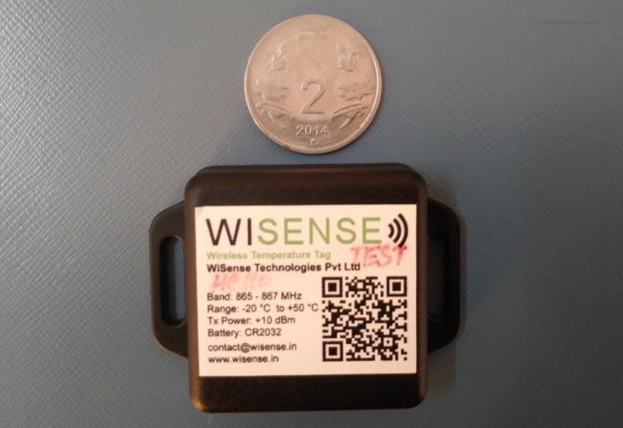

# Product Applications

Suitable for sensing indoor temperatures such as

* Pharmaceutical temperature monitoring
* Cold storages
* Environmental monitoring,

# Product Technical Specifications

* Input supply voltage: 1.8 to 3.0 V DC
* Current consumption: <2 microamps (Sleep mode), 2 micro amps (Active mode)
* Sensing temperature range: -20 deg C to +50 deg C
* Accuracy: ±0.5°C
* Resolution :0.0625 deg C
* Response time: < 1 Second
* Maximum transmit power: +13 dBm
* Wireless range: 100 m
* Antenna Type: PCB
* Dimension: 37mm x 29mm x 8mm



WSN Mesh network



Snapshot of the sensor’s data visualized in the cloud

**Wireless PIR Motion Sensor node**

# Product description

* The Wireless PIR (Passive Infra-red) Motion Sensor detects motion and movement using infrared radiations
* Reports to the central coordinator when a motion is detected
* Each message from sensor data conveys motion detected/not detected status and battery voltage data.
* Powered by 2 x AAA or 2 x AA Batteries or one 1 x Rechargeable LI-Ion (3.7V to 4.2V) battery
* Very low standby mode current consumption of 2 uA allows for long battery life
* Sensor operate in the 865-867 MHz license free band in India.
* Detection area Horizontal 94°, Vertical 82° & Detection distance is 5m

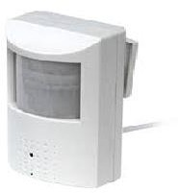

# Product Applications

* Security Systems
* Alarm System
* Motion activated light switch control

# Product Technical Specifications

* Input supply voltage: 3.0 to 5.0 V DC
* Current consumption: <2 microamps
* Operating frequency: 865-867 MHz
* Sensor Detection range: 5 metres
* Sensor detecting Angle: Horizontal 94°, Vertical 82°
* Maximum transmit power: +13 dBm
* Each node has a unique IEEE assigned 64-bit address
* Wireless range: Around 1.0 k.m (line of sight)
* Antenna Type: Half-wave dipole, Gain: +3 dBi
* FCC/ETSI Certified
* Dimensions: 120 mm x 80 mm x 50 mm



WSN Mesh network



Snapshot of the sensor’s data visualized in the cloud

**PT100 Wireless Temperature Sensor**

# Product description

* PT 100 Wireless temperature Sensors measure the range -200 deg C to +550 deg C with ± 0.5 deg C accuracy
* Reports measured temperature periodically with configurable interval - Minimum (1 sec) / Maximum (1 day)
* Reports measured temperature only when it changes by a configurable percentage value with respect to the prior value reported
* Each message from sensor data conveys temperature and battery voltage data.
* Powered by 2 x AAA or 2 x AA Batteries or one 1 x Rechargeable LI-Ion (3.7V to 4.2V) battery
* Very low standby mode current consumption of 2 uA allows for long battery life
* Sensor operate in the 865-867 MHz license free band in India.

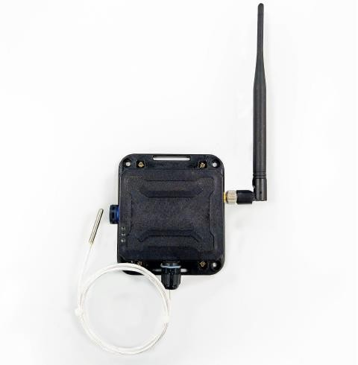

# Product Applications

* Industrial high temperature applications – furnaces, boilers
* Cold storage, ware houses
* Environmental monitoring

# Product Technical Specifications

* Input supply voltage: 3.0 to 5.0 V DC
* Current consumption: <2 microamps (Sleep mode), 2 micro amps (Active mode)
* Sensing temperature range: -220 deg C to +550 deg C
* Accuracy: ±0.5°C (0°C to 85°C)
* Sensor support any 3 wire PT-100/PT-1000 sensor
* Maximum transmit power: +13 dBm
* Each node has a unique IEEE assigned 64-bit address
* Wireless range: Around 1.0 k.m (line of sight)
* Antenna Type: Half-wave dipole, Gain: +3 dBi
* FCC/ETSI Certified
* Dimensions: 120 mm x 80 mm x 50 mm



WSN Mesh network



Snapshot of the sensor’s data visualized in the cloud

# Our Other Products

* Cold Chain Monitor node
* Wireless load Cell monitor node
* Solar Li-ion Charger board
* Wireless weather station
* PIR sensor node
* Door sensor node
* Emergency wall buttons

**Wireless Solar Powered Sensor Node**

# Product description

* Li-Ion solar charger board for wireless nodes
* Texas Instruments based lithium-ion charger IC facilitates auto switchover to battery when external supply is lost
* Up to 2A switch mode charging operation
* Charging current and voltage monitoring through the onboard I2C interface
* Each message from sensor data conveys Solar panel output voltage & current, battery voltage & current data.
* Charger IC can power the load and charge the battery simultaneously.
* Then node includes a thermistor used to monitor the temperature of Li-Ion battery
* I2C, UART, SPI and Analog interfaces for sensor integration

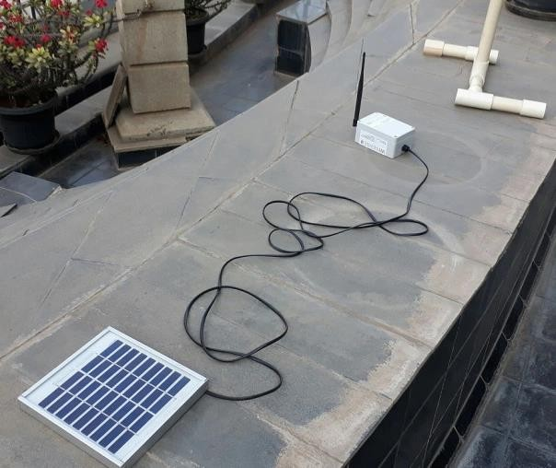

# Product Applications

* Suitable for applications such as running standalone router/sensor node from solar mains with Li-Ion battery backup.
* Powering all kinds of outdoor electronics like wireless sensor

nodes and associated sensors/actuators etc.

# Product Technical Specifications

* Max input (solar panel) voltage: 10.5 V (Vmp)
* Max charge current: 2 A
* Max battery discharge current: 4 A
* Li-Ion battery charged in 3 phases (trickle charge, pre- charge, constant current and constant voltage)
* Maximum transmit power: +14 dBm
* Multiple output voltages (On separate headers/connectors)

o ~3.3V (Max 1 A), 4.9V (Max 50 mA)

* + Li-Ion battery output (Max 4A)
* Voltage output at peak power point (Vmp): 8.5V -8.8V
* Each node has a unique IEEE assigned 64-bit address
* Antenna Type: Half-wave dipole, Gain: +3 dBi

WSN Mesh network

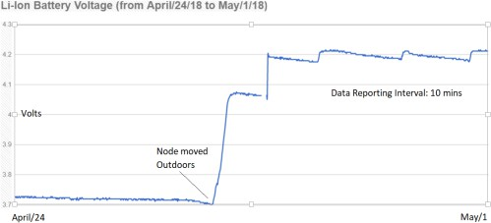Snapshot of Battery voltage data

**Wireless Temperature Sensor Tag**

# Product description

* Wireless temperature sensor Tag uses Industrial grade sensor with a range -25 deg C to +60 deg C.
* Temperature reporting interval can be configured between minimum of once every second to maximum of once every day.
* Each message from sensor data conveys current temperature and battery voltage data.
* Up to 64 such sensor nodes can communicate through one WiSense coordinator node (WSN1120CL)
* Powered by two coin cells (3V CR2032) which can last more than three years assuming 1 transmission every 5 Minutes.
* The tags have an internal PCB antenna but also have a U.Fl connector for an external whip antenna.
* The tags operate in the 865-867 MHz license free band in India.

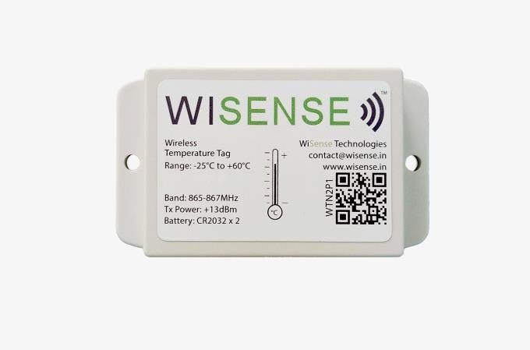

# Product Applications

Suitable for sensing indoor temperatures such as

* Ware houses
* Cold chains
* Environmental monitoring,
* Structures and Machines

# Product Technical Specifications

* Input supply voltage: 1.5 to 3.0 V DC
* Current consumption: <2 microamps (Sleep mode) , 2 micro amps(Active mode)
* Sensing temperature range: -25 deg C to +60 deg C
* Accuracy: 0.25 deg C to 0.5 deg C
* Resolution :0.01 deg C
* Response time: < 1 Second
* Maximum transmit power: +13 dBm
* Wireless range: ~150 m (line of sight)
* Antenna Type: PCB
* Dimension: 90 mm x 52 mm x 18 mm



WSN Mesh network



Snapshot of the sensor’s data visualized in the cloud

**Wireless Water Metering Sensor Node**

# Product description

* Wireless Water metering flow sensors measure the flow reduces water wastage and usage monitoring
* Reports measured consumption data periodically with configurable interval - Minimum (1 sec) / Maximum (1 day)
* Each message from sensor convey flow data and battery voltage data.
* Powered by 2 x AAA or 2 x AA Batteries or one 1 x Rechargeable LI-Ion (3.7V to 4.2V) battery
* Very low standby mode current consumption of 2 uA allows for long battery life
* Sensor operate in the 865-867 MHz license free band in India.
* Measure & send water flow periodically (interval

>= 1 sec) to external entities via network coordinator/gateway

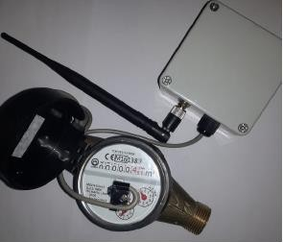

# Product Applications

* Domestic or Industrial water control applications
* Smart water metering/Billing
* Apartments, commercial buildings and communities can build automated reports to analyze usage of water across the community and reduce consumption

# Product Technical Specifications

* Input supply voltage: 3.0 to 5.0 V DC
* Current consumption: <2 microamps (Sleep mode)
* Accuracy: Class 1 / Class 2
* Maximum transmit power: +13 dBm
* Tx. Data rate: 10Kbp

WSN System Architecture



Snapshot of the sensor’s data visualized in the clou

* + Each node has a unique IEEE assigned 64-bit address
  + Wireless range: Around (line of sight)
  + Antenna Type: PCB antenna with U. FL connector
  + Antenna Gain: +3 dBi
  + Supports 2/3-wire pulse output water flow meters

**Wireless Weather station**

# Product description

* Dual wireless temperature sensors Bosch & Texas instruments make, measures -40 deg C to +125 deg C.
* It contains ambient light & atmospheric pressure sensors
* Reporting interval can be configured between minimum of once every second to maximum of once every day.
* Each message from sensor data conveys current temperature and battery voltage data.
* Up to 64 such sensor nodes can communicate through one WiSense coordinator node (WSN1120CL)
* Powered by AA or AAA batteries or Li-ion with solar charging circuit.
* Long range external dipole antenna
* The radio device operates in the 865-867 MHz license free band in India.

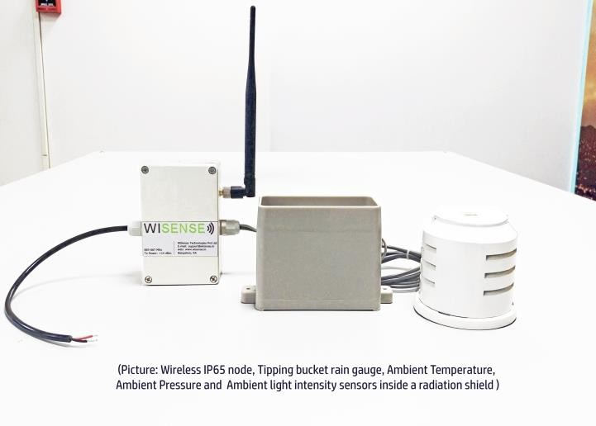

**Product Applications**

* Weather monitoring (Rain measurement)
* Environmental monitoring (ambient light, temperature & pressure)

# Product Technical Specifications

* Input supply voltage: 5.0 to 8.5 V DC
* Current consumption: <2 microamps (Sleep mode) , 2 micro amps(Active mode)
* Sensing temperature range: -40 deg C to +125 deg C
* Pressure range: 300 to 1100 hpa
* Accuracy: 1% (temperature)
* Accuracy :0.047 mm(rain guage)
* Resolution: 0.125 deg C
* Response time: < 1 Second
* Maximum transmit power: +13 dBm
* Wireless range: 1.5k.m (line of sight)
* Antenna Type: Dipole antenna
* IP 65 rating



WSN Mesh network



Snapshot of the sensor’s data visualized in the cloud